Mass Care Services Outreach Survey
for Catastrophic Incident Response

The following questions were asked to those who attended the regional Mass Care Services workshops. Understanding the response to these questions will assist in the development of the Catastrophic Incident Annex and the Catastrophic Incident Planning Framework. Additionally, this information can assist in the development of local, regional, state, and federal regional planning. These questions are also being provided to those who were able to attend a workshop if they wish to add additional information. Please feel free to share these questions with any planning partners that you work with.

IMPORTANT: Do not let the length of this survey deter you from answering these questions. If you are only able to provide limited responses or answer a few questions, this is still better than no information. Mass Care Services planning is vital to our communities and even small steps help make measurable progress.

- The bulleted list below represents those functions of mass care that will were determined by the SCIPT’s catastrophic mass care planning workgroup to have the most impact on the sustainment and saving of human life. The bolded items are those functions that this workgroup will be focusing our planning priorities on first. What are your jurisdictions planning priorities for mass care services?
  - Bulk Distribution
  - Shelter
  - Feeding
  - Hydration
  - Emergency First Aid
  - Mass Evacuation
  - Facilitated Reunification
  - Disaster welfare information
  - Emergency assistance and care for service animals and household pets
  - General, specialized, medical, and non-conventional shelters
  - Transportation to other locations
  - Personal Assistance Services/ Case Management
  - Temporary Housing
Response:

- Have you done any GIS mapping of, or do you know of any research/analysis for your jurisdiction on:
  - Shelter sites & alternate shelter site locations
  - CPOD Locations
  - Feeding & Hydration stations
  - Evacuation Points and Routes
Response (Where can we find this information?):

- For incident types that heavily impact and affect the integrity of state and local transportation systems, it will likely result in the division of communities along temporarily impassable boundaries (e.g., landslides over roadways, collapsed or unsafe bridges, widespread flooding, etc.). This may create population islands, or areas in which the transportation system is not allowing access.
- Have you identified any expected isolated population islands?
  - How long will resources within those population islands last without replenishing?
  - If you have multiple population islands, have you prioritized resource allocation?
Response:

- Do you know of any areas in which you anticipate multiple community lifelines to be non-functional? (See Zone 1 table below: expected permanent/long-term power outage; expected severe/permanent water facility damage and long-term water outages; expected long-term damage to health care systems, etc.) These would be areas you would consider evacuating and bringing the people out of a dangerous area and TO the resources, as opposed to pushing resources into an area that might not be sustainable.
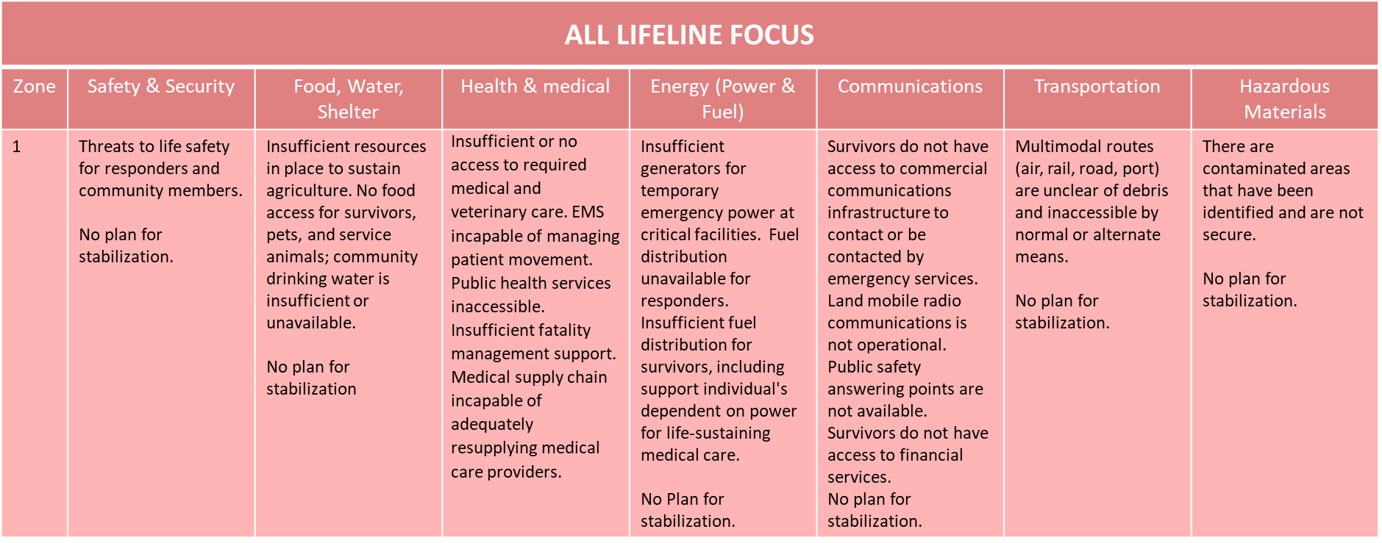
Response:

- Sheltering sites will need to be assessed after incident types like earthquakes (to include significant aftershocks). Identification of the available resources within each jurisdiction will assist determining potential gaps where outside resources are needed to meet the needs.
- Who are your primary partners for damage assessments?
- Do you have any contractor MOA/MOUs in place?
  - Have you deconflicted your MOA/MOUs with nearby jurisdictions?
- Do you have any workarounds should your main damage assessors be unavailable?
Response:

- Not all jurisdictions approach damage assessments in the same manner, have the same timelines, or utilize identical resources. Gaining an understanding of the items below can assist in determining how to best support an impacted jurisdiction. Please describe how you would perform damage assessments of:
  - POD locations
  - Shelter sites
Response:

- Information collection, analysis, and dissemination are key to establishing situational awareness during initial response. What Essential Elements of Information (EEIs) do you need immediately post impact to perform lifesaving/life sustaining mass care services and/or evacuation?
Response:

- Following a catastrophic incident there will be many tasks to complete to establish mass care operations and services. Not all jurisdictions may perform specific actions or place priorities in the same order. The bulleted items below are examples of some assessments that you might want to complete immediately post incident. Please describe your Mass Care Services assessment priorities (after your initial Windshield Surveys/Rapid Needs):
  - Shelter Structural Integrity Assessment?
  - Supply Chain Assessment Priorities?
  - Capability Needs Assessment Priorities?
  - Resource Needs Assessment Priorities?
  - Sheltering Operation Assessment Priorities?
  - Sheltering Needs Assessment Priorities?
  - Other?
Response:

- Local resources can be expected to be depleted quickly or otherwise impacted, presenting sustainment limitations for mass care emergency services. Using the list below, please indicate how long you expect your onsite and/or immediately available resources to last for:
  - Shelter operations
  - Feeding operations
  - Hydration operations
Response:

- Are your shelter facilities self-sustainable? (i.e., do they have generators, fuel storage (and permitting), water storage, and feeding services available to allow it to be self-sufficient for any number of days). How long could your facility be self-sustainable without resupply or outside assistance?
Response:

- What are the challenges to increasing your sheltering capacity? For example, think if you had to suddenly double your capacity, what challenges or barriers would immediately prevent you from succeeding?
Response:

- One of the many issues that will arise from an incident which covers large geographic areas and political boundaries will be the reliance on similar resources and service providers. Pre-identifying potential conflicts that can arise from competing resources will assist in determining the capability to provide mass care services in a catastrophic incident. Are there MOA/MOU for mass care or housing support services within your jurisdiction?
- With neighboring jurisdictions?
- Have you done deconfliction of your mass care service providers with neighboring jurisdictions?
Response:

- During a catastrophic incident there will be a need for a variety of different shelter types. Do you have shelters that perform different functions? (Examples below)
  - Pet shelters?
  - Livestock shelters?
  - Medical shelters?
  - Other?
Response:

- Who other than the American Red Cross can or will be doing sheltering operations in your county/region? Do they have staff identified and trained to support sheltering operations?
Response:

- Following a disaster that separates family members, efforts to support family reunification will be essential to begin as soon as possible. What gaps to implementing family reunification services have you identified?
Response:

- Who other than the American Red Cross, can or will do feeding operations (has training, supplies, equipment, and standards)?
- Do you have any supplies stored for immediate use post incident?
    - How long will that supply last before needing re-supply?
Response:

- What are the challenges to increasing your feeding, hydration, & bulk distribution capacity? For example, think if you had to suddenly double your capacity, what challenges or barriers would immediately prevent you from succeeding?
Response:

