- Concept of Operations
  - The Evacuation/Shelter-in-Place phase begins when a threat requires evacuation or shelter-in place operations, either following or concurrent with mobilization phase activities, depending on incident notice. For no-notice events, this is the first phase and mobilization may happen both outside and within the impact area as part of the response. This phase includes implementing the protective actions of evacuation and shelter-in-place orders, which will vary depending on the size and scope of the incident. This phase may be used in advance of the impact phase for notice events (e.g., wildfire) or after the impact phase for no-notice or low-notice events (e.g., earthquake, terrorist attack) to meet incident objectives and protect life and property.
  - Key Elements
    - Implementing Protective Actions
      - Evacuation Orders
        - Evacuation Levels - Ready, Set, GO!
          - Ready, Set, GO! evacuation levels correspond to geographically specific areas where a hazard has occurred and/or has the potential to affect. These areas are designated as zones on a map and should be provided to the Public.
        - Level 1 – Ready
          - Occupants of this zone are informed and alerted of the incident and hazard. Occupants are also alerted at the potential for protective actions based on further developments to the incident.
        - Level 2 – Set
          - Occupants of this zone are informed and alerted of the incident and hazard. Occupants are also alerted to be prepared to leave with limited or no notice.
        - Level 3 – GO!
          - Occupants of this zone are informed and alerted of the incident and hazard. Occupants are directed to immediately leave the affected area.
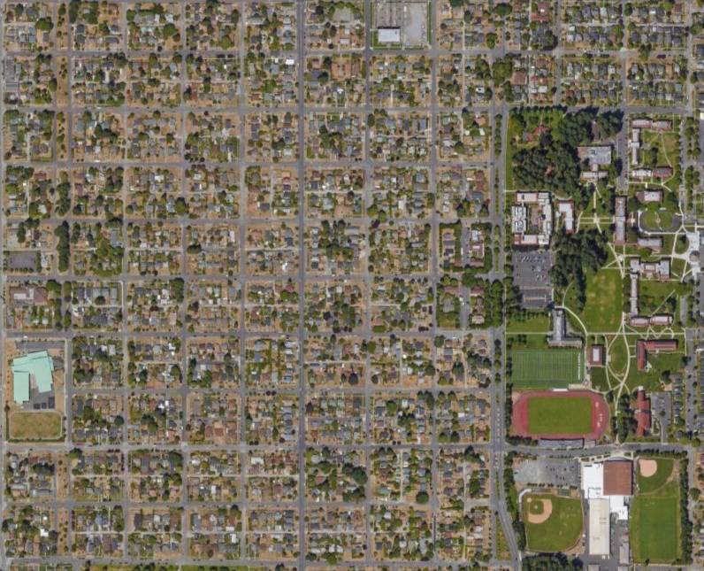
GO!
Ready
Set
Figure 1 - Ready, Set, GO! example
      - Shelter-in-Place Orders
      - Initiating Evacuation
        - Zonal Approach
          - The goal of an evacuation is to move as few people as needed the shortest distance to safety. Zone-based evacuation reduce resource burdens, facilitate re-entry, and accelerate the transition to recovery. A zone-based approach requires a unified effort to understand and coordinate evacuation and shelter-in-place actions, and make informed decisions based on the appropriate transportation models.
          - Establishing evacuation and shelter-in-place zones allows for targeted evacuation to the most vulnerable zones, while limiting the need for evacuating large areas that are not under the threat of the hazard. Generally, geographic considerations for zone boundaries include U.S. Census Blocks, neighborhood boundaries, fire/police districts, and ZIP codes.
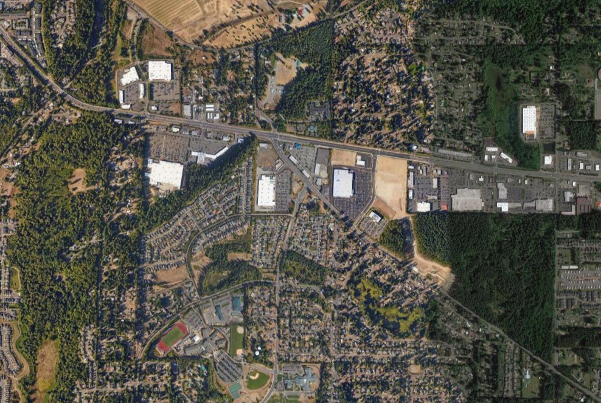
Zone 2
Zone 3
Zone 1
Zone 4
Zone 5
Figure 2 - Evacuation Zones example

        - Evacuation Transportation Models
          - Hub and Spoke
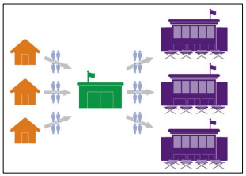
            - This model moves and aggregates evacuees in short trips from numerous pickup locations to evacuation centers, which in turn provide evacuation to mass care centers. Hub and spoke maximizes routes and provides immediate movement of people from dangerous locations to a safer location temporarily. This transportation model allows jurisdictions to triage the needs of individuals, which may only be access to temporary shelter or access to personnel to facilitate the rental of a vehicle or other means to evacuate and provide care for themselves and their family directly.
Figure 3 - Hub and Spoke Model
          - Point-to-Point
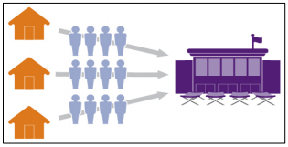
            - This model moves evacuees directly from the point of embarkation to a host jurisdiction or shelter. Point-to-point is the fastest, most direct and streamlined, and least resource-intensive evacuation action in the immediate operational period. However, it has limited capacity for surges during large displacements. Shelters can come to capacity quickly, increasing travel for evacuees. Additionally, this model is not ideal if the host location has not been determined, such as in the instance of no-notice events that have a wide and unpredictable pattern.
Figure 4 - Point-to-Point Model
    - Operational Objectives, Priorities, and Critical Considerations
      - Life-safety and Incident Stabilization
        - Objectives will be influenced by issuing either evacuation or shelter-in-place orders. These objectives should consider all of the following Critical Considerations:
- Accessibility
- Children and Accompanied Minors
- Homeless Populations
- Individuals with Access and Functional Needs
- Household Pets and Service Animals
- Tourist Populations
- Mass Care and Sheltering Services
- Hospitals and Residential Medical Facilities
- Correctional Facilities
- Fuel Management
- Traffic Management
- Contraflow Lane Reversal
- Evacuation Clearance Time
- Zonal Approach
- Tracking/Evacuee Accountability

  - Community Lifelines
    - During the Evacuation/Shelter-in-Place phase lifelines will likely not have experienced many impacts until later phases. As status reports come into the EOC through departments, stakeholders, and partners the current lifeline status should be completely known by the end of this phase. Statuses that are still unknown could greatly impact planned efforts centered around high levels of coordination and limited resources. If all of the lifelines are unimpacted they will be displayed in green (“Stable”).

Figure 5 - Community Lifelines example

  - Core Capabilities
Core Capabilities
Planning | Conduct a systematic process engaging the whole community as appropriate in the development of executable strategic, operational, and/or tactical-level approaches to meet defined objectives.
Public Information and Warning | Deliver coordinated, prompt, reliable, and actionable information to the whole community through the use of clear, consistent, accessible, and culturally and linguistically appropriate methods to effectively relay information regarding any threat or hazard, as well as the actions being taken, and the assistance being made available, as appropriate.
Operational Coordination | Establish and maintain a unified and coordinated operational structure and process that appropriately integrates all critical stakeholders and supports the execution of Core Capabilities.
Critical Transportation | Provide transportation (including infrastructure access and accessible transportation services) for response priority objectives, including the evacuation of people and animals, and the delivery of vital response personnel, equipment, and services into the affected areas.
Environmental Response/Health and Safety | Conduct appropriate measures to ensure the protection of the health and safety of the public and workers, as well as the environment, from all hazards in support of responder operations and the affected communities.
Logistics & Supply Chain Management | Deliver essential commodities, equipment, and services in support of impacted communities and survivors, to include emergency power and fuel support, as well as the coordination of access to community staples. Synchronize logistics capabilities and enable the restoration of impacted supply chains.
On-Scene Security, Protection, and Law Enforcement | Ensure a safe and secure environment through law enforcement and related security and protection operations for people and communities located within affected areas and also for response personnel engaged in lifesaving and life-sustaining operations.
Operational Communications | Ensure the capacity for timely communications in support of security, situational awareness, and operations, by any and all means available, among and between affected communities in the impact area and all response forces.
Situational Assessment | Provide all decision makers with decision-relevant information regarding the nature and extent of the hazard, any cascading effects, and the status of the response.

  - Critical Tasks
Planning
Critical Task I.D. | Critical Task Description
1 | Develop operational plans that adequately identify critical objectives based on the planning requirement, provide a complete and integrated picture of the sequence and scope of the tasks to achieve the objectives, and are implementable within the timeframe contemplated in the plan using available resources.

Public Information and Warning
Critical Task I.D. | Critical Task Description
1 | Inform all affected segments of society of critical lifesaving and life-sustaining information by all means necessary, including accessible tools, to expedite the delivery of emergency services and aid the public to take protective actions.

Operational Coordination
Critical Task I.D. | Critical Task Description
1 | Mobilize all critical resources and establish command, control, and coordination structures within the affected community, in other coordinating bodies in surrounding communities, and maintain as needed throughout the duration of an incident.

Critical Transportation
Critical Task I.D. | Critical Task Description
1 | Establish physical access through appropriate transportation corridors and deliver required resources to save lives and to meet the needs of disaster survivors.

Environmental Response/Health and Safety
Critical Task I.D. | Critical Task Description
1 | Identify, assess, and mitigate worker health and safety hazards, and disseminate health and safety guidance and resources to response and recovery workers.
2 | Minimize public exposure to environmental hazards through assessment of the hazards and implementation of public protective actions.

Logistics and Supply Chain Management
Critical Task I.D. | Critical Task Description
1 | Mobilize and deliver governmental, nongovernmental, and private sector resources to save lives, sustain lives, meet basic human needs, stabilize the incident, and transition to recovery, to include moving and delivering resources and services to meet the needs of disaster survivors.

On-Scene Security, Protection, and Law Enforcement
Critical Task I.D. | Critical Task Description
1 | Establish a safe and secure environment in an affected area.

Operational Communications
Critical Task I.D. | Critical Task Description
1 | Ensure the capacity to communicate with both the emergency response community and the affected populations and establish interoperable voice and data communications between Federal, tribal, state, and local first responders.

Situational Assessment
Critical Task I.D. | Critical Task Description
1 | Deliver information sufficient to inform decision making regarding immediate lifesaving and life-sustaining activities, and engage governmental, private, and civic sector resources within and outside of the affected area to meet basic human needs and stabilize the incident.

- Responsibilities
Response | Critical Task I.D. | Activity/Action | Organization(s) Involved
Planning | 1 | Issuing and Implementing Evacuation/Shelter-in-Place Orders
Public Information and Warning | 1
Operational Coordination | 1
Critical Transportation | 1
Environmental Response/Health and Safety | 1, 2
Logistics and Supply Chain Management | 1
On-Scene Security, Protection, and Law Enforcement | 1
Operational Communications | 1
Situational Assessment | 1
Operational Coordination | 1 | Example: Activate personnel and transportation partners to support the Evacuation and Shelter-in-Place phase. | Public Works
Critical Transportation | 1
Operational Coordination | 1 | Example: Implement contraflow operations, if authorized. | Law Enforcement, Emergency Management, Public Works, PIO
Public Information and Warning | 1
Critical Transportation | 1
Environmental Response/Health and Safety | 1, 2
On-Scene Security, Protection, and Law Enforcement | 1
Critical Transportation | 1 | Example: Implement access controls to close transportation infrastructure, entrances, and/or exits determined unsafe. | Public Works, Law Enforcement
Environmental Response/Health and Safety | 1, 2
On-Scene Security, Protection, and Law Enforcement | 1
Situational Assessment | 1
Critical Transportation | 1 | Example: Adjust traffic signal timing and implement other systems to expedite outbound traffic flow and public transit, in conjunction with: | Emergency Management, Public Works, Law Enforcement
On-Scene Security, Protection, and Law Enforcement | 1
Situational Assessment | 1
Planning | 1 | Communicating Protective Actions to the Public
Public Information and Warning | 1
Environmental Response/Health and Safety | 1, 2
Operational Communications | 1
Situational Assessment | 1
Planning | 1 | Example: Implement communications plan for responders to communicate to the affected population. | Emergency Management, PIO, Fire Services, Law Enforcement
Public Information and Warning | 1
Operational Communications | 1
Public Information and Warning | 1 | Example: Activate variable-message signs (VMS) and other messaging capabilities | Emergency Management, Public Works
Operational Communications | 1
Planning | 1 | Communicating Protective Actions to Response Agencies, Departments, Organizations, Partners, and Other Stakeholders
Public Information and Warning | 1
Operational Coordination | 1
Environmental Response/Health and Safety | 1, 2
Logistics and Supply Chain Management | 1
Operational Communications | 1
Situational Assessment | 1
Logistics and Supply Chain Management | 1 | Example: Activate mobilized assets, including staging areas, roadway support, and evacuation sites | Emergency Management, Public Works, Law Enforcement
Operational Coordination | 1 | Example: Maintain streetlights, traffic signals, and other evacuation-related systems in conjunction with private sector energy businesses. Utilize alternate power sources as available. | Public Works, Private Sector
Planning | 1 | Example: Determine zero-hour criteria for halting operations and sheltering personnel (wind speed, flooding conditions, inaccessible locations, hazardous material exposure limits). Communicate these criteria to workers and responders. | Emergency Management, Senior or Elected Officials, Fire Services, Law Enforcement
Public Information and Warning | 1
Environmental Response/Health and Safety | 1, 2
Situational Assessment | 1
Environmental Response/Health and Safety | 1, 2 | Example: Identify Safety/PPE Needs and Distribute PPE. Upon assignment of responders to the incident, maintain continuous monitoring of responder safety and health, proper functioning of PPE and equipment, and awareness of on-site hazards. | All Departments, Safety Officers
Situational Assessment | 1
Planning | 1 | Vertical Communications to External Stakeholders (i.e. City to County, County to State, County to Tribe, etc.)
Public Information and Warning | 1
Operational Coordination | 1
Logistics and Supply Chain Management | 1
Operational Communications | 1
Situational Assessment | 1
Operational Coordination | 1 | Example: Survey current resources and request additional resources, as necessary. | Emergency Management
Logistics and Supply Chain Management | 1
Situational Assessment | 1
Operational Coordination | 1 | Example: Track Response activities (ICS Forms, WebEOC, etc.) and communicate vertically. | Emergency Management
Situational Assessment | 1
Planning | 1 | Initiate Evacuation Transportation Model (“Hub and Spoke” or “Point to Point”)
Public Information and Warning | 1
Operational Coordination | 1
Critical Transportation | 1
Environmental Response/Health and Safety | 1, 2
Logistics and Supply Chain Management | 1
On-Scene Security, Protection, and Law Enforcement | 1
Operational Communications | 1
Situational Assessment | 1
Planning | 1 | Example: Track resource requirements for those with CTN, persons with disabilities, and others with access and functional needs evacuees, those with health and medical needs, and household pets and service animals. | Emergency Management, Public Health, Human Services
Critical Transportation | 1
Logistics and Supply Chain Management | 1
Situational Assessment | 1
Critical Transportation | 1 | Example: Remove damaged/immobile vehicles from the primary evacuation routes. | Public Works, Law Enforcement, Fire Services
Planning | 1 | Example: Develop transportation objectives and priorities for the Impact Phase. | Emergency Management
Critical Transportation | 1
Logistics and Supply Chain Management | 1
Situational Assessment | 1
Logistics and Supply Chain Management | 1 | Example: Provide fuel support for evacuation operations. | Emergency Management, Public Works
Critical Transportation | 1
Logistics and Supply Chain Management | 1 | Example: Determine need for private sector transportation resources. | Emergency Management, Private Sector
Critical Transportation | 1
Situational Assessment | 1

