City/County Name
Executive Playbook

Page kept blank for formatting purposes

Responsibilities  - Before a disaster  - After a disaster | 1
Conference Calls  - Regional Policy Call | 5
Policy Issues  - Disaster Specific policy issues  - Emergency legal authorities  - Proclamation process | 15
Reference Materials  - Key messages  - Contact information  - Relevant City/County Code and Ordinances | 23
Table of Contents

Responsibilities

• Before a disaster
• During a disaster

What do to BEFORE a disaster

Plan
• Have an up-to-date Continuity of Operations Plan
• Ensure you have contacted your City Attorney or Prosecuting Attorney for information on legal requirements
• Make sure you know Key Messages and have them vetted through the Joint Information Center for consistency
Personal Preparation
• Prepared a communications plan with your family and other loved ones.
• Create a personalized kit for yourself and family.
• Make sure you have at least 3 days of supplies at your work and in your car.
Practice
• Attend tabletop exercises and other trainings when able.
• Go over your key messages quarterly to ensure they are still
relevant.

What do to DURING a disaster

Keep Government Running
• Formulate major policy issues
• Preserve the continuity of the Executive Branch of County government
• Coordinate emergency operations and provide liaison, as required
• Make emergency proclamations when needed
Request Support
• Request Mutual Aid and assistance from other counties or states when needed through the Emergency Operations Center.
Information
• Provide leadership and play a key role in communicating to the public disaster information and directions.
• Inform the public through the use of the Joint Information Center
Regional Coordination
• Interface with county, local, and regional chief executives.
• Hold policy calls with regional executives, to discuss regional issues.

Page kept blank for formatting purposes

Conference Calls
How decisions are made

• Regional Policy Call

Regional Policy Call

Call information

Purpose: To determine the need to adjust current or establish new County-wide policies and/or to enact emergency powers which limit or infringe upon civil liberties.
When: during activations requiring review of regional policy issues
Requested by: Jurisdictional Executive Officer
Issued by: The jurisdictions Regional Emergency Coordination/Operations Center
Time: as needed
Chair : County Executive (or designee)
Attendees: regional city and county executive officers, policies-makers, or their designee

Request Process

• The Mayor or Incident Manager will request a regional policy call by contacting their Regional Emergency Coordination/Operations Center.
• The Regional Emergency Coordination Center will set up a conference line and notify the necessary participants.
• The call will follow a set agenda (see next page) focused on the issue or issues at hand.
• There will be a policy briefing document to supplement the call. The briefing document will be filled in by the Incident Manager
• If there is an necessary follow-up it will be decided during the call and the Regional Emergency Coordination Center will make arrangements for follow-up.

Regional Policy Call Agenda

- Roll Call | King County Executive
- Situation update and description of issue | King County Office of Emergency Management
- Review of legal authorities | King County Prosecuting Attorney
- Policy issues  - Policy issue #1  - Discussion  - Decision  - Policy issue #2  - Discussion  - Decision | All
- Summary of decisions | All

Contact Information
City Attorney/ Prosecuting Attorney
Name
(xxx) xxx-xxxx
Email

Regional Coordination Center contact:
ESF 15 Coordinator
(xxx)xxx-xxxx
E-mail

Page kept blank for formatting purposes
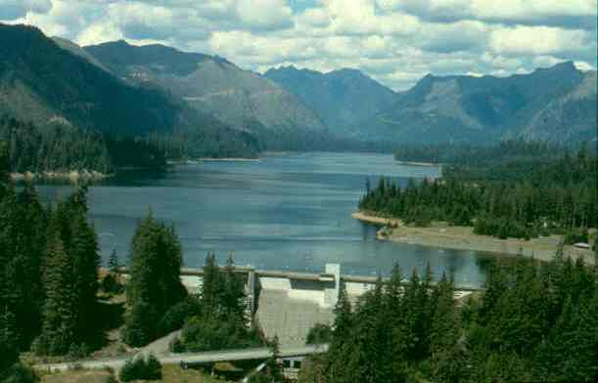
Policy Issues

- Incident specific policy guide
- Proclamation
- Emergency legal authorities

Incident specific policy guide
Disaster specific

The following describes policy issues that could arise during a certain disaster or emergency. These pages are intended to help guide you in which topics to pay close attention to since they may be impacted.

Hazard: Landslide
Potential Policy Issues:
• Debris management
• Transportation
• Support of evacuated individuals/businesses
- Media messaging
- Public visibility of Mayor

Hazard: Dam Failure
Potential Policy Issues:
• Request to federal agencies
• Media messaging
• Public visibility of Mayor
• Debris management
• Transportation
• Support of evacuated individuals/businesses

Hazard: Flood
Potential Policy Issues:
• Request to federal agencies
• Media messaging
• Public visibility of Executive
• Debris management
• Transportation
• Support of evacuated individuals/businesses
• Housing

Hazard: Earthquake
Potential Policy Issues:
• Employee leave/human resources/ safety of County facilities
• Financial impacts
• Housing
• Public visibility of Executive
• Media messaging
• Permits
• Debris management
• Support for evacuated individuals/businesses
• VIP visits
• Transportation

Hazard: Severe Weather (winter storm, blizzard, extreme heat, drought, extreme cold, lighting)
Potential Policy Issues:
• Media messaging
• Human resources/employee leave
• Transportation
• Support for regional shelters
• Debris management

Hazard: Volcano
Potential Policy Issues:
• Employee leave/human resources/ safety of County facilities
• Financial impacts
• Housing
• Public visibility of Executive
• Media messaging
• Permits
• Debris management
• Support for evacuated individuals/businesses
• VIP visits
• Transportation

Emergency Proclamation Process

Purpose: The purpose of a proclamation is: to utilize one or more emergency powers or to request assistance from the state in the form of
tangible resources or possibly, reimbursement for emergency costs associated with the incident.
When: During an emergency where there are results that include:
• Death or injury
• Destruction of Property
• Extraordinary measures to protect the public peace, safety and welfare of the public.
Issued by: Mayor/ County Executive (or designee)

Creation Process

• Decision is made to proclaim a state of emergency. There must be a justification for emergency powers.

• Through policy call
• Policy meeting
• Executive can act alone

• Notify Emergency Operations Center (EOC) of decision to proclaim an emergency, if not done so already. They will draft the proclamation using the following information:
• What specific emergency power are being invoked
• Justification for each power
• Conditions of proclamation

• The mayor will receive a DRAFT document sent through e-mail or a paper copy. This draft will have already been reviewed by County Administrative Officer, Budget officer, and legal counsel.

• The Prosecuting Attorney’s Office will provide the Executive with the FINAL copy to be signed.

• Once the final copy is signed, ESF 15 must be notified to begin work on related documents (press releases, talking points, etc.) and to notify other emergency management organizations.

Emergency Proclamation Example

Insert example of a proclamation in the format used in your jurisdiction.

Emergency legal authorities

Purpose: The following are powers granted under law and local code for use during exceptional incidents.
Located in: Location of emergency legal authorities
Issued by: Mayor/ County Executive (or designee)

Powers Include:

• Insert powers granted under local code and law.

Page kept blank for formatting purposes
I
Reference Materials

• Key messages
• Contact information
• Relevant City/ County Code and Ordinances

Key Messages

Civil Unrest/ Riots
• Law enforcement, fire, and emergency management agencies have joined forces in a coordinated response.
• For your safety, if you are in an area of unrest, stay indoors away from windows to avoid injury from possible flying debris.
• Report any fires, violence, or suspicious activity in your area by calling 9-1-1.

Earthquakes
• Enter city or county regional response plan is in effect. We are coordinating with police and emergency personnel to reach people in need as quickly as possible and restore essential services.
Tips
Public Communication
- What happened and where it happened
- What we know; don’t know
- What county government is doing about it and why
- When conditions may improve
- How people can stay safe, informed, and support response efforts

Employee Communication
- Communicate any known facts
- Provide clear policy directives:
- “If you are at work….”
- “If you are at home…”
- Share ways to say informed
- Direct them to website & hotline
• Expect strong aftershocks. When the ground shakes, “drop, cover and hold” under a sturdy table until shaking stops.
• Check for personal injuries, gas leaks and fires that may have started
Severe Weather
• Listen to weather forecasts regularly and heed any warnings.
• Check on neighbors, especially anyone who might need extra help.
• Register for list possible alert mechanisms

Terrorism/Bomb Threats
• Be aware of your surroundings and call 9-1-1 to report suspicious activity.
• Locate your nearest evacuation routes.
• Do not block sidewalks or other areas used by emergency officials.

Tsunamis/Volcanic Eruptions
• Listen to your radio, NOAA weather radio, or TV for updates on conditions and evacuation information.
• Evacuate if advised to do so by authorities.
• After a volcanic eruption, be prepared to stay indoors and avoid downwind areas if ashfall is predicted. Protect your lungs and eyes, and minimize travel – ash can be irritating and harmful to you and your vehicle.
Flooding
• Listen for news reports to learn whether the community’s water supply is safe to drink.
• Avoid contact with floodwater; it may be contaminated by chemicals or raw sewage.
• Stay away from downed power lines.
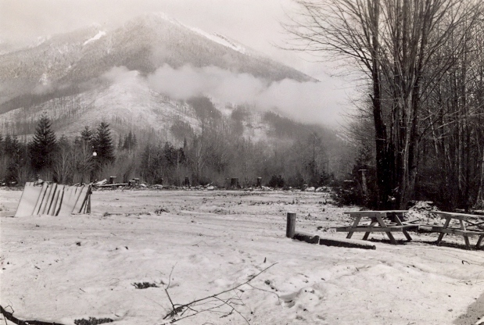

Contact Information

City & County Contact links
City officials
Association of Washington Cities
Association of Washington Counties
EOC Contacts
Incident Manager | (xxx) xxx-xxxx
Public Information Officer | (xxx) xxx-xxxx
Emergency Management Director | (xxx) xxx-xxxx
City Contacts (remove if county)
City Attorney | (xxx) xxx-xxxx
City Manager or City Clerk | (xxx) xxx-xxxx
County Contacts
Incident Manager | (xxx) xxx-xxxx
Prosecuting Attorney | (xxx) xxx-xxxx
Joint Information Center | (xxx) xxx-xxxx
State Contacts
Washington State Governor’s office | (xxx) xxx-xxxx
Washington State Emergency  Management Division | (xxx) xxx-xxxx

Relevant City/County Codes
Description | Location
Description | Location
Relevant City/County Plans
Comprehensive Emergency Management Plan
Discusses the role of emergency management in the County
Continuity of Operations Plan
Explains how the County will continue operations during an emergency
Regional Hazard Mitigation Plan
Outlines mitigation strategies and projects within the County
Regional Coordination Framework for Disasters and Planned Events
Explains the way jurisdictions will coordinate during a disaster
City/County Codes & Plans

Page kept blank for formatting purposes

This document is brought to you by The Regional Catastrophic Preparedness Grant Program and the King County Office of Emergency Management. This document should be reviewed for correctness once a year.

