Dear <Contact>

You are invited to join your fellow Washingtonians, and participate in the seventh annual Great Washington ShakeOut! On October 18th, at 10:18 am, registered individuals, schools, businesses, organizations, and families all over all over the world will “Drop, Cover, and Hold on,” in an earthquake drill to encourage awareness and preparedness. Washington State alone had over 1.1 million participants in each of the past three years, joining millions more across the country and around the world.

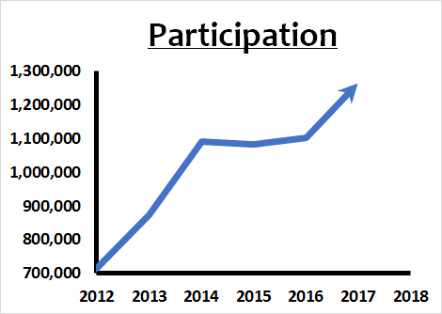
We need your help to continue increasing participation!

Washington State has the 2nd highest earthquake risk in the United States. With at least fifteen named surface fault structures, a history of damaging deep earthquakes like the 2001 Nisqually Earthquake, the Cascadia Subduction Zone off the coast, and new faults constantly being discovered by improved mapping technology, it is only a matter of time before the next earthquake strikes. When that happens, having practiced the drill will help you and your family/ business/organization have the muscle memory in place to react quickly and appropriately. An earthquake can be an extremely disruptive natural event to our way of life. Getting prepared now will help you to get back to your daily life more quickly.

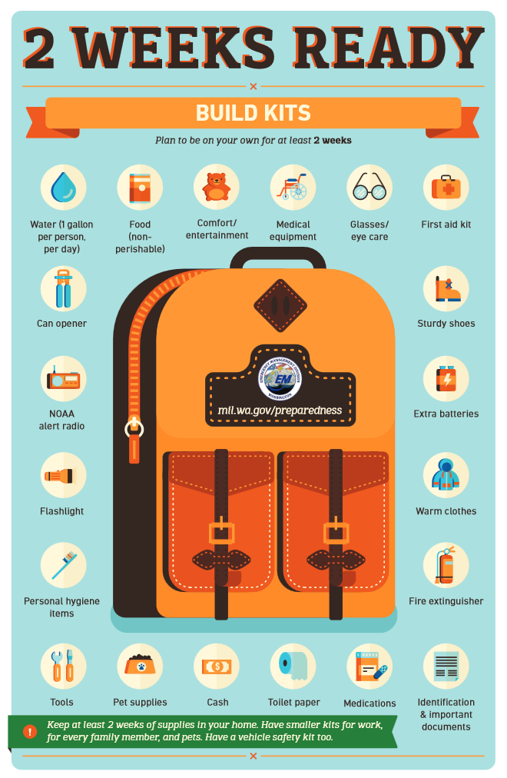

For even greater participation, and to develop a more well-prepared and resilient Washington State, we are asking for your help to encourage greater community involvement. The Great Washington ShakeOut drill emphasizes the theme of creating a more aware and prepared Pacific Northwest for all earthquake and tsunami hazards. In addition to participating in the drill, and testing the Tsunami sirens, participants are encouraged to use this opportunity for other preparedness activities, including:
- Review and update emergency preparedness plans and supplies
- Secure objects to help prevent damage and injuries
- Establish out-of-area contacts to aid post-disaster communication
- Create or refresh emergency kits
- Evaluate earthquake insurance options
- Update or practicing established continuity plans
- If coastal: Add “Practice tsunami evacuation routes”

Regardless of their location, these steps will help participants prepare themselves, their families, or their businesses for all types of disasters which may affect Washington.

Registration is simple! Just sign onto www.shakeout.org/washington, click “Register Here!” and follow the steps to register yourself, your family, or your organization. Feel free to also check out www.shakeout.org/statistics to see how the numbers in your registration category compare to other groups around the state and the country, in this year and previous years. Encourage others in your field to participate! Additionally, in case 10:18 am on 10/18/2018 is not a convenient time for you, we still encourage you to register, and participate in the drill at another time!

The Shakeout website “resources” page offers numerous materials, including suggestions for earthquake drills, instructional videos and flyers, pertaining to a wide variety of sector-specific needs (e.g. business, school, healthcare, elderly, people with access and functional needs, etc.). We encourage you to review and utilize the resources that are applicable to your needs. Attached is a general flyer <Attach 2-sided Shakeout poster> with information on the event, some examples of home and business preparedness tips and a list of weblinks if you’re interested in learning more about Washington’s Earthquake hazards . Remember, every step you take towards earthquake preparedness is a positive step for your family, organization, neighborhood, and/or community, and for supporting the state’s overall preparedness.

We hope that you can join us, and “Shake Out” with your fellow Washingtonians this October. We are here to help support you in making this training opportunity as easy, beneficial to your organization, and fun as possible. Please do not hesitate to reach out to us for more information and/or assistance in developing your drill preparations.

Thank you,

<You>

