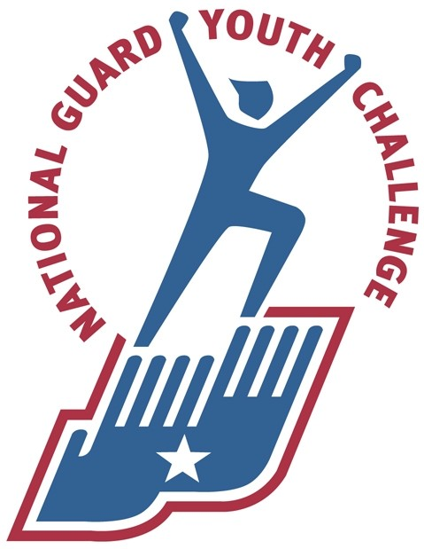

Youth Academy Physical Abilities Test (YAPAT)

Note: All scenarios will be performed in athletic attire (i.e. shorts/sweats-t-shirt/sweatshirt-running shoes).
Scenario 1: Emergency Response Test (each event must be completed as described below to pass)
- Sit and Stand: Sit in chair and stand up unaided.
- Bend and Reach: Pick up small item off floor.
- Stair Descent: Continue from the above events to the stairs and descend 23 steps (2 flights) safely to the bottom of the stairs as if responding to an emergency. Safely ascend the 2 flights of stairs, returning to the test starting point, again as if responding to an emergency.
- Drag: Drag “Juvenile Rescue Randy” (145lbs) 35 feet.
- Stair Climb: From the end of the drag portion respond back to the stairs and safely descend and ascend the stairs, returning to the test starting point.
- Crawl: Crawl 20 ft on floor-Scenario ends.
Scenario 2: Physical Fitness Instruction/Demonstration Test (each exercise must be explained and demonstrated to pass)
The following exercises will be explained and demonstrated to the testing board. While or after demonstrating, 10 repetitions will be performed. Candidates may use the attached exercise descriptions for reference during the scenario and the candidate explanation and demonstration is not required to be memorized.

Scenario 3: 15 Minute Continuous Run (must continuously run/jog at your own pace to pass)
The last test is the 15 minute continuous run. The applicant will be led to the testing area and will demonstrate running (without stopping, walking, or speed walking) for 15 minutes. Applicants can run and set their own pace.
**If you have questions regarding this test please contact the Academy Human Resource Consultant at (360)-473-2622 or patricia.acoba@mil.wa.gov.

*EITHER THE SEATED OR STANDING HAMSTRING STRETCH MAY BE DEMONSTRATED.

*EITHER THE SEATED OR STANDING GROIN STRETCH MAY BE DEMONSTRATED.

Curl-Ups
Lie on a cushioned, clean surface with your knees flexed and feet about 12 inches from your buttocks. Place your hands on the opposite shoulders with your arms crossed. Have a partner hold your feet and count your curl-ups. Holding your elbows close to your chest, raise your trunk up to touch your elbows to your thighs. A complete curl-up is counted for each time you lie back and touch your shoulders to the floor. Do as many curl-ups as you can in one minute. (Note-Applicant will demonstrate 10 complete curl-ups either during or after describing the exercise)

Right Angle Push-Ups

You should lie face down on a mat in
the push-up position with your hands
under your shoulders, fingers straight;
your legs should be straight, parallel,
and slightly apart with your toes
supporting your feet. Straighten your
arms, keeping your back and knees
straight while you lower your body until
there is a 90-degree angle at your
elbows and your upper arms are parallel
to the floor, then push back up. Do one
push-up every three seconds until you
cannot complete one at this pace.
(Note-Applicant will demonstrate 10
complete Right Angle Push-Ups either
during or after describing the exercise)

35 feet is the rescue standard for WA Fire Candidate Physical Ability Test CPAT http://www.ci.seattle.wa.us/fire/employment/ffjob_physicalAgility.htm.
Army Field Manual 21-20 (pp 4-3 thru 2-13)
This exercise test is designed to measure the applicant’s ability to run continuously, which simulates leading a Cadet formation run lasting 15-20 minutes.
US Department of Health and Human Services. (2008) Get Fit and Be Active!, The President’s Challenge Physical Activity & Fitness Awards Program, Handbook (p. 13)
US Department of Health and Human Services. (2008) Get Fit and Be Active!, The President’s Challenge Physical Activity & Fitness Awards Program, Handbook (p. 14)

